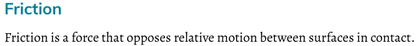

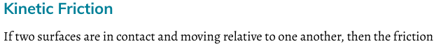

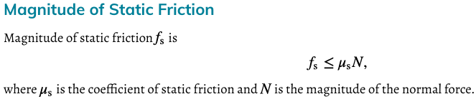

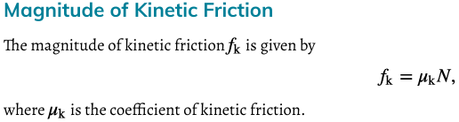

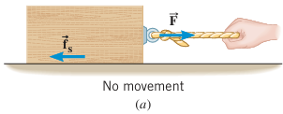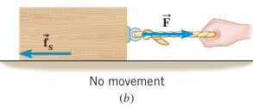
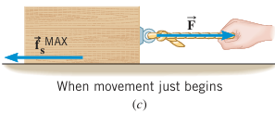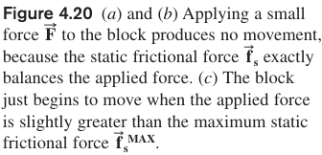
Summary of Frictional Force:
- Opposes the direction of motion
- Caused by contact between two separate surfaces
- Parallel to the surface of contact
Depends on
- the type of surface (“stickness factor”)
- the normal force of the object
Two Types:
- Static (f_{s}, prevents objects from moving, has a threshold)
- Kinetic (f_{k}, occurs while objects are moving, less than static)

Sled Riding: The person (mass 60 kg) is sliding on the snow. The coefficient of kinetic friction is 0.2. Find the kinetic friction, her acceleration, and the distance x
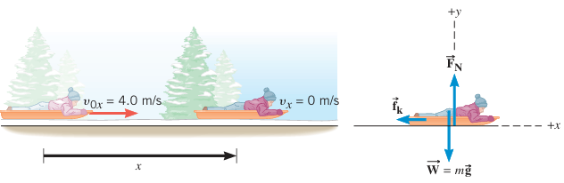

Free Body Diagram with Frictions
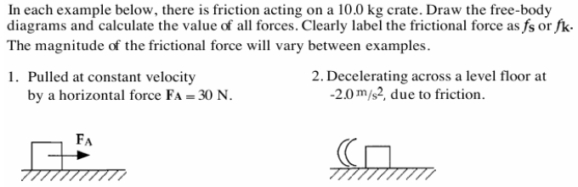

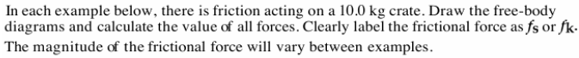
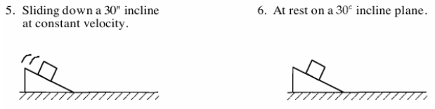

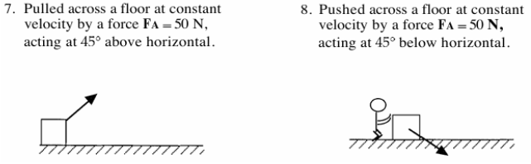

Static Friction: Kinetic Friction: (Fn is the magnitude of the normal force)

Understanding Static and Kinetic Friction
